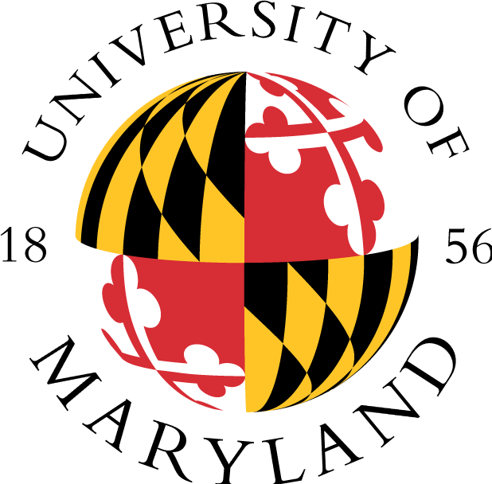

ACADEMIC ACHIEVEMENT PROGRAMS
Ronald E. McNair Post-Baccalaureate Achievement Program
2110 Marie Mount Hall * College Park, MD 20742
(P) 301.405.4749 * (F) 301.314.7255 * mcnairscholar@umd.edu
http://www.aap.umd.edu/mcnairprogram.html

RESEARCH SUMMARY PROFILE SHEET

(Please keep to one page. Please type all information, send to McNair office, share with mentor, and place in Scholar Portfolio. Please revise this profile when interests change.)

Date Submitted

Scholar’s Name (Full Name)

Major (Full Name)

Department (Full Name)

College (Full Name)

Scholar’s Mentor (Full Name)

Research Topic or Title

Research Summary

Research Question(s)

Research methods | [] Mixed methods [] Qualitative methods [] Quantitative methods
Desired Graduate Schools

Ultimate Academic Degree | Ph.D.

